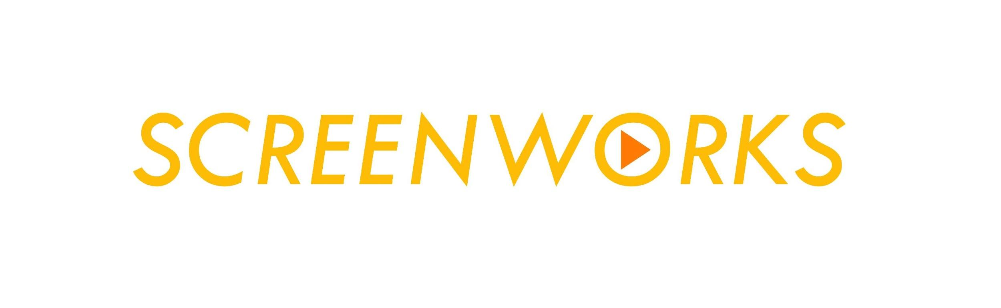

Submission Form
Contributor’s name:
Contributor’s email:
Institution:
Details for publication: | Title:  Author/s:  Format:  Running Time:
Vimeo URL or website: | http://
Vimeo Password:
Permission:  Please refer to the Vimeo compression guidelines and ensure your video is downloadable. | I have made the video downloadable for review, future publication and archiving.  I give permission for you to embed the above URL in the Screenworks.org.uk website.  I take responsibility for ensuring the work adheres to UK copyright guidelines.  The practice and research statement have not been previously published by an academic peer-reviewed journal, nor are they being considered for or awaiting publication elsewhere, unless they are substantially different (e.g. addressing different research questions).

Criteria
- What criteria would you suggest that reviewers use in order to assess the research (these might most easily be derived from the initial research questions)?
Viewing Conditions
- Please indicate if there are any specific viewing conditions you would like the work to be seen in i.e. screen resolution, size of image, etc., etc.:
Review Responses
Review responses are likely to fall into the following categories :

- Accept work and statement for DVD and web publication.
- Accept work but require revision of statement.
- Invite resubmission with re edit of work and/or statement.
- Reject both work and statement.

Formative and Summative Responses
Clearly the question of re-editing finished work for many researchers will not be possible – e.g. where film prints have been struck or online edits locked off. However in some cases researchers may want formative peer review at ‘rough cut stage’.

In the case of e.g. smaller scale digital productions it may be possible to re-edit the work in order to resubmit.

Please tick (or underline) whether you would like a formative or summative response.

Supporting Research Statement
(Expand text boxes as necessary, but limit yourself to a maximum of 2000 words long)
We are looking for evidence of Originality, Significance and Rigour and “contribution to new knowledge and understanding” in your chosen field of practice.

Research Questions
- Be as specific as you can in articulating what you were trying to achieve.
- What were your starting points?
- How do these questions relate to the field as a whole?
Context
- What work already exists in the relevant fields of practice?
- How do you expect to be able to advance on work that already exists?
- How does this work fit into your own personal research trajectory?
- Is it part of a body of work?
- Please include a bibliography / filmography at the end.
Methods
- Which disciplinary fields do your methods derive from (e.g. Fine Art, Graphics, Industrial TV production , Video art, Experience Design etc., etc.)?
Outcomes
- What might other practitioners in the field learn from the work?
Dissemination
- How was the work funded?
- Where has the work been shown? Was this in competition?
- Has it been recognised through curatorial selection, distribution, festival exhibition, prizes or awards? Are there any reviews?
- What other dissemination has there been (e.g. conference presentations, website documentation, etc.)?
Impact
- what demonstrable contribution has your practice made to the economy, society, culture, national security, public policy or services, health, the environment, or quality of life, beyond contributions to academia.
Additional Information

Submission Check list:

I’ve uploaded my screenwork / video documentation onto Vimeo
I’ve included the URL
I’ve included the password (where necessary)
I’ve completed all sections of the supporting statement
I’ve saved this document as lastname_statement.doc

Please save your statement as a word document with the following title structure:
lastname_statement.doc and return by email to: admin@screenworks.org.uk with “Screenworks Submission” in the subject line.

